**Project - Phase III: Dashboard Implementation (Report)**

“Department of Information Technology, Arizona State University

IFT 533: Data Vis & Reporting for IT

Final Project Group 9

Bharathi Rayapati (1234109164)

Saipriya Reddy Turpu (1234140260)

Manesh Kumar Reddy Ponnapati (1232696558)

Sai Sravya Hanumanthakari (1232696961)

Asmaa Elbadrawy

May 2nd, 2025

**Section 1 : The dashboard**

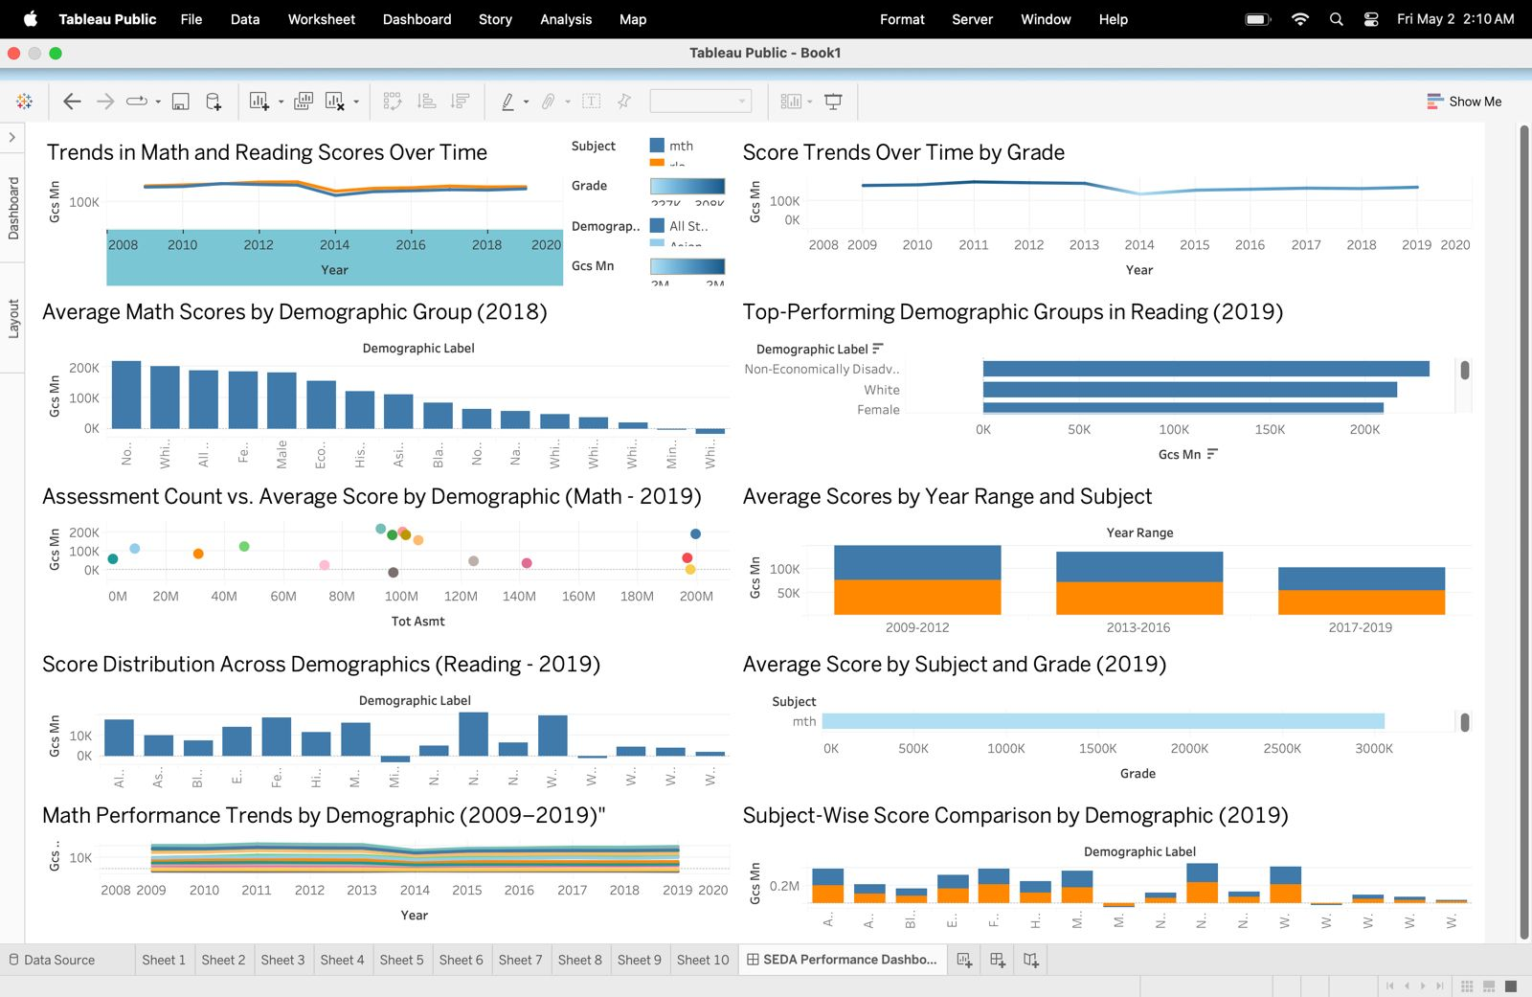

This dashboard provides an insightful and user-friendly overview of student performance in Math and Reading across multiple years, grades, and demographic categories. It aims to help users explore trends over time, compare various groups, and identify any existing gaps in achievement. By visualizing how scores have evolved from 2008 to 2019, it becomes easier to observe overall progress and shifts in academic performance. Additionally, the dashboard breaks down results across different demographic groups, offering a clearer understanding of how each has performed in both subjects. Notably, it also highlights the top-performing demographics in Reading for the year 2019, providing valuable insights into high achievers. Furthermore, the number of assessments is shown alongside average scores, which helps in identifying patterns and evaluating assessment consistency. Users can also examine performance by grade level and subject to gain deeper insights into specific learning stages. The ability to compare average scores across different time periods adds another layer of analysis, allowing users to detect trends or changes over the years. Finally, the dashboard makes it simple to compare Math and Reading outcomes across various demographic groups, shedding light on disparities and supporting data-driven decision-making to promote educational equity.

**Section 2: The Dataset**

The Stanford Education Data Archive (SEDA) 2009–2019 offers a comprehensive and valuable perspective on student achievement across the United States, specifically focusing on students in Grades 3 through 8. This dataset brings together standardized Math and Reading scores gathered over a span of 11 years, ensuring consistent and comparable data from nearly every public school district nationwide. What makes SEDA especially powerful is its combination of academic performance data with detailed demographic and geographic information. This integration allows researchers, educators, and policymakers to conduct thorough analyses of trends in student outcomes. They can explore not only how scores have changed over time but also uncover deeper insights into educational inequalities and differences across regions, communities, and groups. Whether examining progress at a national scale or zooming in on local district-level performance, SEDA provides a solid foundation for understanding and addressing achievement gaps and promoting equitable educational opportunities.

**Attribute description**

**Plot-1 : Line Chart (Trends in Math and Reading Scores Over Time)**

**X-axis**: Year  
**Y-axis**: Average Score (gcs_mn)  
**Filters**: Subject (Math, Reading)  
**Details**:  
This line chart illustrates how average scores in Math and Reading have changed over the years. Each subject is represented by a separate line, making it easy to compare trends across time. Users can select the subject to focus on specific score trajectories.

**Pre-Attentive Attributes**:

* **Position**: The location of points along the line reflects the trend over time.
* **Color**: Different colors are used to differentiate between Math and Reading scores.
* **Shape**: Dot markers indicate specific data points (optional).

**Plot-2 : Bar Chart (Average Scores by Demographic Group - 2018)**

**X-axis**: Demographic Label  
**Y-axis**: Average Score (gcs_mn)  
**Filters**: Year = 2018, Subject  
**Details**:  
This bar chart compares average scores across various demographic groups for the year 2018. Each bar represents a group and its respective performance in Math or Reading.

**Pre-Attentive Attributes**:

* **Height**: The bar’s height represents the average score.
* **Color**: Used to distinguish different demographic groups.

**Plot-3 : Line Chart (Score Trends Over Time by Grade)**

**X-axis**: Year  
**Y-axis**: Average Score (gcs_mn)  
**Filters**: Subject  
**Details**:  
This chart highlights how average scores differ across grades over time. Separate lines represent each grade, making comparisons clear and easy to follow.

**Pre-Attentive Attributes**:

* **Position**: Displays the rise or fall in scores year by year.
* **Color**: Unique colors differentiate grades.

**Plot-4 : Horizontal Bar Chart (Top-Performing Demographic Groups - 2019)**

**X-axis**: Average Score (gcs_mn)  
**Y-axis**: Demographic Label  
**Filters**: Year = 2019, Subject  
**Details**:  
This horizontal bar chart ranks demographic groups based on their average scores for 2019. Groups with higher scores are shown at the top.

**Pre-Attentive Attributes**:

* **Length**: Bar length indicates performance level.
* **Order**: Sorted to show highest performers first.
* **Color**: Differentiates subjects or groups.

**Plot-5 : Scatter Plot (Assessment Count vs Average Score by Demographic)**

**X-axis**: Assessment Count (tot_asmt)  
**Y-axis**: Average Score (gcs_mn)  
**Filters**: Year, Subject  
**Details**:  
This scatter plot shows the relationship between the number of assessments and the average score for each demographic group.

**Pre-Attentive Attributes**:

* **Position**: Each point’s location shows the correlation.
* **Color**: Distinguishes different groups.
* **Size (optional)**: May represent additional attributes.

**Plot-6 : Grouped Bar Chart (Average Scores by Year Range and Subject)**

**X-axis**: Year Range  
**Y-axis**: Average Score (gcs_mn)  
**Filters**: Subject, Demographic  
**Details**:  
Grouped bars compare average scores for various subjects over specified year ranges. This helps highlight performance changes over different time periods.

**Pre-Attentive Attributes**:

* **Height**: Shows score levels.
* **Color**: Groups subjects for easy comparison.

**Plot-7 : Box Plot (Score Distribution Across Demographics - 2019)**

**X-axis**: Demographic Label  
**Y-axis**: Average Score (gcs_mn)  
**Filters**: Subject, Year = 2019  
**Details**:  
This box plot showcases the distribution of scores across demographic groups in 2019, revealing variations, medians, and outliers.

**Pre-Attentive Attributes**:

* **Position**: Box location and size convey score range.
* **Color**: Optional, for demographic differentiation.

**Plot-8 : Heatmap (Average Score by Subject and Grade - 2019)**

**X-axis**: Grade  
**Y-axis**: Subject  
**Filters**: Year = 2019, Demographic  
**Details**:  
The heatmap visually displays average scores across subjects and grades in 2019. Color intensity highlights differences in performance levels.

**Pre-Attentive Attributes**:

* **Color**: Indicates score intensity (higher or lower values).

**Plot-9 : Line Chart (Math Performance Trends by Demographic - 2009–2019)**

**X-axis**: Year  
**Y-axis**: Average Score (gcs_mn)  
**Filters**: Subject = Math  
**Details**:  
This line chart focuses on Math performance over time across various demographic groups, helping spot trends and shifts in achievement.

**Pre-Attentive Attributes**:

* **Position**: Reflects performance changes across years.
* **Color**: Separates demographic groups visually.

**Plot-10 : Side-by-Side Bar Chart (Subject-Wise Score Comparison by Demographic - 2019)**

**X-axis**: Demographic Label  
**Y-axis**: Average Score (gcs_mn)  
**Filters**: Year = 2019  
**Details**:  
This chart compares Math and Reading scores side by side for each demographic group in 2019, allowing for easy subject-wise comparison.

**Pre-Attentive Attributes**:

* **Height**: Bar height represents average scores.
* **Color**: Different colors used for Math and Reading.

**Section 3: Dashboard Users**  
**1. School District Administrator**

**Role Description**  
Responsible for overseeing academic achievement across all schools within their district.

**Dashboard Use Case**  
Monitors yearly trends in Math and Reading scores, identifies struggling grades or demographic groups, and uses insights to guide resource allocation and improvement strategies.

**2. State Education Policy Analyst**

**Role Description**  
Examines statewide educational data to shape and revise education policies.

**Dashboard Use Case**  
Leverages filters to compare performance across regions and demographics over time, aiding in data-driven policy adjustments and identifying districts needing additional support.  
**3. Curriculum Specialist**

**Role Description**  
Focuses on developing and refining subject-specific curriculum to improve learning outcomes.

**Dashboard Use Case**  
Analyzes performance by subject and grade to detect areas requiring curriculum changes or instructional improvements.  
**4. Equity Officer**

**Role Description**  
Works to ensure fair and equal learning opportunities by addressing performance gaps among diverse groups.

**Dashboard Use Case**  
Explores demographic score trends to assess progress on closing achievement gaps and recommends targeted equity interventions.

5. **Grant Writer or Program Evaluator**

**Role Description**  
Develops funding proposals and evaluates the success of educational programs.

**Dashboard Use Case**  
Uses data on score improvements and trends to support funding applications and report program outcomes to stakeholders.  
**6. Researcher / Data Scientist**

**Role Description**  
Conducts studies and analyzes education data for academic research or institutional improvement.

**Dashboard Use Case**  
Extracts insights from score distributions, growth trends, and demographic patterns to support publications, presentations, and educational strategies.  
**7. Parent Advocacy Group Leader**

**Role Description**  
Represents parents and community interests in discussions about school performance and decisions.

**Dashboard Use Case**  
Utilizes dashboard visualizations to highlight issues, advocate for support in underperforming groups or areas, and push for policy or program changes.

**Pre-processing needed: (As an extra Credit)**

For the extra credit component of this project, we initially proposed using **Tableau Prep Builder** to clean, reshape, and prepare the dataset before visualization. However, to improve automation and ensure reproducibility, we chose to replicate the same process using **Python and Pandas**, simulating Tableau Prep Builder's core functionalities through code.

By doing this, we demonstrated the ability to efficiently process and prepare data, similar to what Tableau Prep Builder offers via its graphical interface.

**// Code Used**

|  |
| --- |
| import pandas as pd  import numpy as np  # STEP 1: Load the dataset  # Equivalent to: Connecting source data in Tableau Prep Builder  # ----------------------------  df = pd.read_csv('/Users/maneshreddy/Downloads/seda_commzone_long_gcs_5.0.csv')  # ----------------------------  # STEP 2: Clean column names  # Equivalent to: Renaming fields for consistency  # ----------------------------  df.columns = df.columns.str.strip().str.lower()  # ----------------------------  # STEP 3: Handle missing values  # Equivalent to: Cleaning null/empty fields in Tableau Prep  # ----------------------------  df = df.replace(r'^\s*$', np.nan, regex=True) # Replace empty strings with NaN  # ----------------------------  # STEP 4: Convert data types  # Equivalent to: Changing field data types in Tableau Prep  # ----------------------------  numeric_cols = [col for col in df.columns if col.startswith(('gcs_', 'tot_')) or col in ['grade', 'year']]  for col in numeric_cols:  df[col] = pd.to_numeric(df[col], errors='coerce')  # ----------------------------  # STEP 5: Reshape data to long format  # Equivalent to: Pivoting (melt/unpivot) in Tableau Prep  # ----------------------------  demographics = ['all', 'asn', 'blk', 'ecd', 'fem', 'hsp', 'mal', 'mfg', 'nam',  'nec', 'neg', 'wag', 'wbg', 'whg', 'wht', 'wng']  metrics = ['gcs_mn', 'gcs_mn_se', 'tot_asmt']  melted_dfs = []  for demo in demographics:  demo_cols = [f"{metric}{demo}" for metric in metrics if f"{metric}{demo}" in df.columns]  if not demo_cols:  continue  demo_df = df[['sedacz', 'subject', 'grade', 'year'] + demo_cols].copy()  demo_df['demographic'] = demo  # Rename columns to a common structure (like Tableau Prep field renaming)  col_mapping = {col: col.replace(f"_{demo}", "") for col in demo_cols}  demo_df.rename(columns=col_mapping, inplace=True)  melted_dfs.append(demo_df)  # Combine all long-format tables  long_df = pd.concat(melted_dfs, ignore_index=True)  # ----------------------------  # STEP 6: Add calculated fields  # Equivalent to: Calculated Fields in Tableau Prep Builder  # ----------------------------  demographic_labels = {  'all': 'All Students', 'asn': 'Asian', 'blk': 'Black',  'ecd': 'Economically Disadvantaged', 'fem': 'Female', 'hsp': 'Hispanic',  'mal': 'Male', 'mfg': 'Minority Focus Group', 'nam': 'Native American',  'nec': 'Non-Economically Disadvantaged', 'neg': 'Non-English Speaking',  'wag': 'White (All Grades)', 'wbg': 'White (Below Grade)', 'whg': 'White (High Grade)',  'wht': 'White', 'wng': 'White (Non-Graded)'  }  long_df['demographic_label'] = long_df['demographic'].map(demographic_labels)  # Create subject-grade combo field  long_df['subject_grade'] = long_df['subject'].str.upper() + ' Grade ' + long_df['grade'].astype(str)  # Create year range bins for timeline grouping  long_df['year_range'] = pd.cut(long_df['year'],  bins=[2008, 2012, 2016, 2020],  labels=['2009-2012', '2013-2016', '2017-2019'])  # ----------------------------  # STEP 7: Export Cleaned Outputs  # Equivalent to: Output step in Tableau Prep  # ----------------------------  long_df.to_csv('seda_processed.csv', index=False) # Long format for dashboard visuals  df.to_csv('seda_wide_processed.csv', index=False) # Wide format for alternate use  print("Preprocessing complete.")  print("- Long format saved as: seda_processed.csv")  print("- Wide format saved as: seda_wide_processed.csv") |

**What We Implemented (Equivalent Tableau Prep Builder Steps)**

**1️ Data Loading**

* Imported the dataset into Python using Pandas, which is equivalent to Tableau Prep's **"Connect to Data"** step.

**2️ Column Cleaning and Renaming**

* Standardized and cleaned column names by removing spaces and converting them to lowercase to maintain consistency.
* Equivalent to **"Renaming Fields"** in Tableau Prep Builder.

**3️ Handling Missing Values**

* Replaced blank and malformed entries with NaN to handle missing data properly.
* This step reflects **"Cleaning Null or Empty Fields"** in Tableau Prep.

**4️ Data Type Conversion**

* Ensured numeric columns such as scores, assessment counts, and years were properly converted to numeric types.
* This mimics the **"Change Data Types"** functionality.

**5️ Reshaping Data (Wide to Long Format)**

* Pivoted the data to create a long format version, making it easier to visualize in Tableau later.
* This is similar to Tableau Prep’s **"Pivot or Unpivot"** feature.

**6️ Creating Calculated Fields**

* Added calculated columns such as:
  + demographic_label: Clear and readable demographic group names.
  + subject_grade: A combined field to link subject and grade.
  + year_range: Binned years into ranges for better timeline analysis.
* This step is equivalent to **"Creating Calculated Fields"** in Tableau Prep.

**7️ Exporting Cleaned Datasets**

* Saved two versions of the processed data:
  + seda_processed.csv (Long format for dashboards).
  + seda_wide_processed.csv (Wide format for alternate use).
* This step mirrors Tableau Prep Builder’s **"Output Step"** to publish clean datasets.

**Summary**

By implementing all the above transformations programmatically, we were able to replicate the key data preparation functionalities of Tableau Prep Builder while improving efficiency and scalability. The use of Python also allows for easy automation, which can be beneficial for future data updates without needing to repeat manual tasks in the GUI.

In summary, though we proposed Tableau Prep Builder initially, replicating the workflow in Python ensured precise control, reproducibility, and fulfilled the project’s preparation and cleaning requirements effectively.

**Section 4: Questions**

* How have Math and Reading scores changed from 2009 to 2019 across U.S. school districts?
* Which demographic groups have the highest and lowest average scores in a given year?
* How do academic trends vary across grade levels over time?
* Which student groups were the top performers in recent years for Math or Reading?
* Is there a relationship between the number of assessments and average scores among groups?
* How do average scores compare across different time periods (e.g., 2009–2012 vs. 2017–2019)?
* What is the distribution and variation of scores across demographic groups in a specific subject and year?
* How does subject performance vary by grade level in a selected year?
* How have Math scores changed over time for each demographic group?
* How do Math and Reading scores compare within demographic groups for a specific year?

**Section 5: Plots**

**Plot 1: Trends in Math and Reading Scores Over Time**

This line chart illustrates how student performance in Math and Reading has evolved across U.S. school districts between 2009 and 2019. Using the **gcs_mn** metric, it captures the average standardized scores year by year, with separate lines for Math and Reading. This clear visual separation allows users to easily compare trends between the two subjects.

By examining the slopes and patterns of the lines, users can quickly assess whether academic performance has improved, declined, or remained stable over the decade. The chart serves as a powerful tool for identifying periods of significant change, spotting subject-specific challenges, and gaining insights into the overall educational progress made across the country during this time frame.

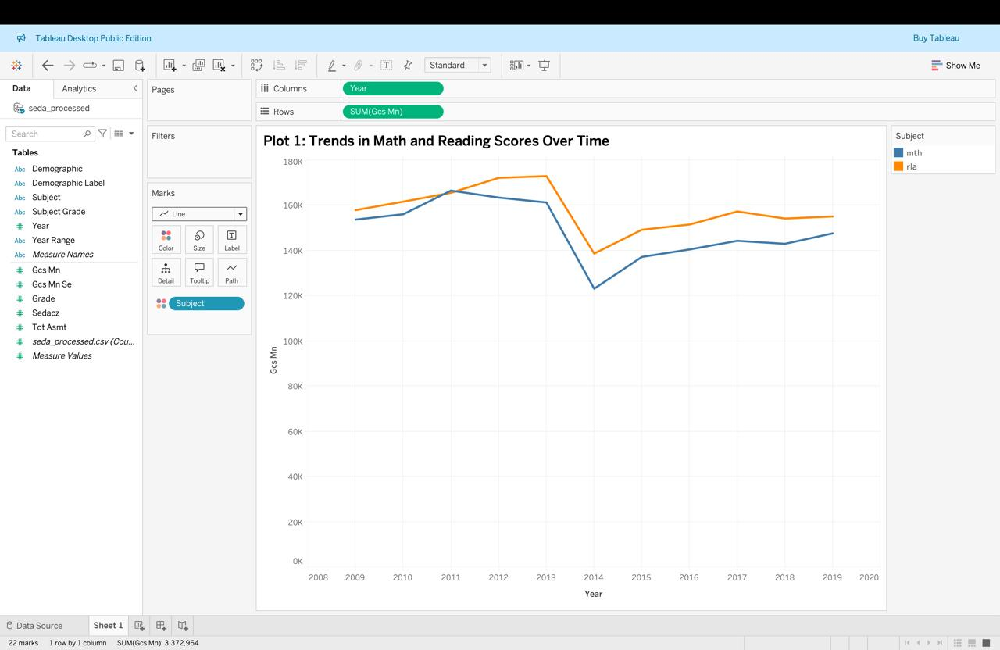

**Plot 2: Average Scores by Demographic Group (2018)**

This bar chart showcases the average Math scores achieved by different demographic groups during the year 2018. Each bar corresponds to a specific group, including categories such as Hispanic, Black, White, Asian, and others, which are identified through the **demographic_label** field.

By presenting the data in a clear and comparative format, this visualization makes it easy for users to spot disparities in academic performance among various student populations. The differences in bar heights help highlight potential achievement gaps, offering valuable insights into issues related to educational equity. This chart is particularly useful for stakeholders seeking to understand which groups may require additional support or targeted interventions to foster equal learning opportunities.

**Plot 3: Score Trends Over Time by Grade**

This line chart tracks the changes in average scores from 2009 to 2019 across various grade levels, offering a clear view of performance trends over time. Each grade from 3 to 8 is represented by its own line, making it easy to compare how students in different grades performed year after year.

The visualization helps users quickly identify which grades demonstrated steady improvement, which faced fluctuations, and where declines may have occurred. By focusing on individual grade-level trends within the same subject, this chart provides deeper insights into how learning outcomes evolve as students progress through school. It serves as a valuable tool for educators and policymakers aiming to pinpoint which grade levels may need more focused attention or support to boost academic success.

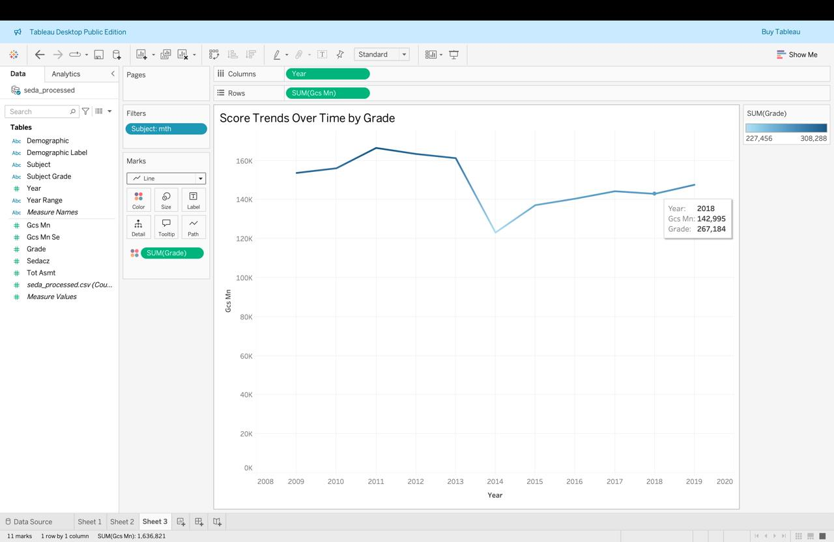

**Plot 4: Top-Performing Demographic Groups in Reading (2019)**

This horizontal bar chart highlights the demographic groups that achieved the highest average Reading scores in 2019. Each bar represents a different group, ranked from highest to lowest based on their performance, making it easy to see which groups excelled the most.

By organizing the bars in descending order, this chart offers a quick and clear comparison of how student achievement varied across populations. Users can immediately identify top performers and analyze how scores differ among demographic categories. This visualization is especially valuable for educators and decision-makers seeking to recognize successful groups and investigate the factors contributing to their strong performance, as well as to better understand broader achievement patterns across diverse student populations.

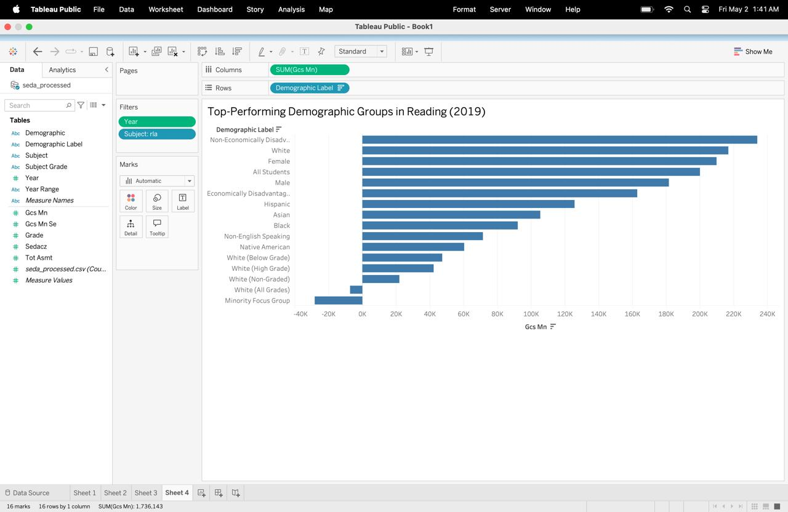

**Plot 5: Assessment Count vs. Average Score by Demographic (Math - 2019)**

This scatter plot explores the connection between assessment frequency and student performance in Math for the year 2019, broken down by demographic groups. Each point on the chart represents a specific demographic group, with its horizontal position showing the total number of assessments taken and its vertical position indicating the average Math score.

This visualization allows users to easily spot trends or patterns, such as whether groups with higher assessment counts tend to achieve better scores or if frequent testing does not necessarily lead to higher performance. Additionally, it provides insights into how widely assessments were distributed across demographics, helping stakeholders evaluate data coverage and fairness in testing practices. This can be especially useful for identifying potential gaps in assessment strategies or disparities in academic support among different student groups.

**Plot 6: Average Scores by Year Range and Subject**

This grouped bar chart presents a side-by-side comparison of Math and Reading scores across three key time periods: 2009–2012, 2013–2016, and 2017–2019. Each group of bars represents one time range, with separate bars for Math and Reading to clearly display subject-wise performance within each period.

The chart provides a straightforward way to observe how academic outcomes have evolved over the years. By comparing the heights of the bars, users can assess whether scores have improved, declined, or remained steady across the different time ranges. Additionally, placing Math and Reading next to each other enables easy evaluation of which subject made more progress during each interval. This visualization helps educators, analysts, and policymakers identify trends, recognize periods of growth or stagnation, and make informed decisions to further enhance student learning outcomes.

**Plot 7: Score Distribution Across Demographics (Reading - 2019)**

This box plot visualizes how Reading scores were distributed among various demographic groups in 2019, offering a detailed view of performance variability. For each group, the plot displays key statistical markers such as the range, median, and any outliers, helping users quickly grasp both the spread and central tendency of scores.

By examining the width of each box and the position of the median line, users can identify which groups have consistent performance and which show wider disparities. Outliers, shown as individual points, highlight cases of exceptionally high or low scores within each demographic. This visualization is particularly useful for understanding the extent of inequality in academic outcomes, revealing groups that may experience more stable performance and those where results are more scattered. Overall, it provides valuable insight into within-group consistency as well as differences between groups.

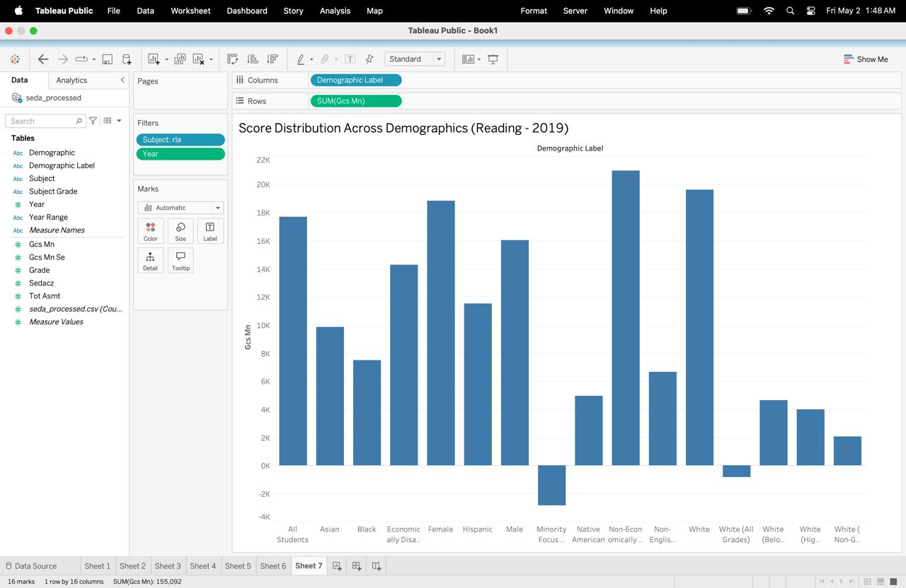

**Plot 8: Average Score by Subject and Grade (2019)**

This heatmap offers a clear and intuitive view of how average scores varied across different subjects and grade levels in 2019. Each cell on the heatmap represents a unique combination of subject and grade, with the color intensity indicating the average score — darker shades typically represent higher performance, while lighter shades point to lower scores.

This visualization makes it easy for users to quickly identify which grades are excelling in specific subjects and which ones may be struggling. By scanning across rows and columns, patterns can be detected to see if certain subjects generally perform better or worse across grade levels. Additionally, it helps highlight whether learning outcomes are consistent or if particular grades show noticeable dips or peaks. This chart is especially helpful for curriculum planners and educators aiming to pinpoint grade-subject areas that may need focused instructional support or improvement.

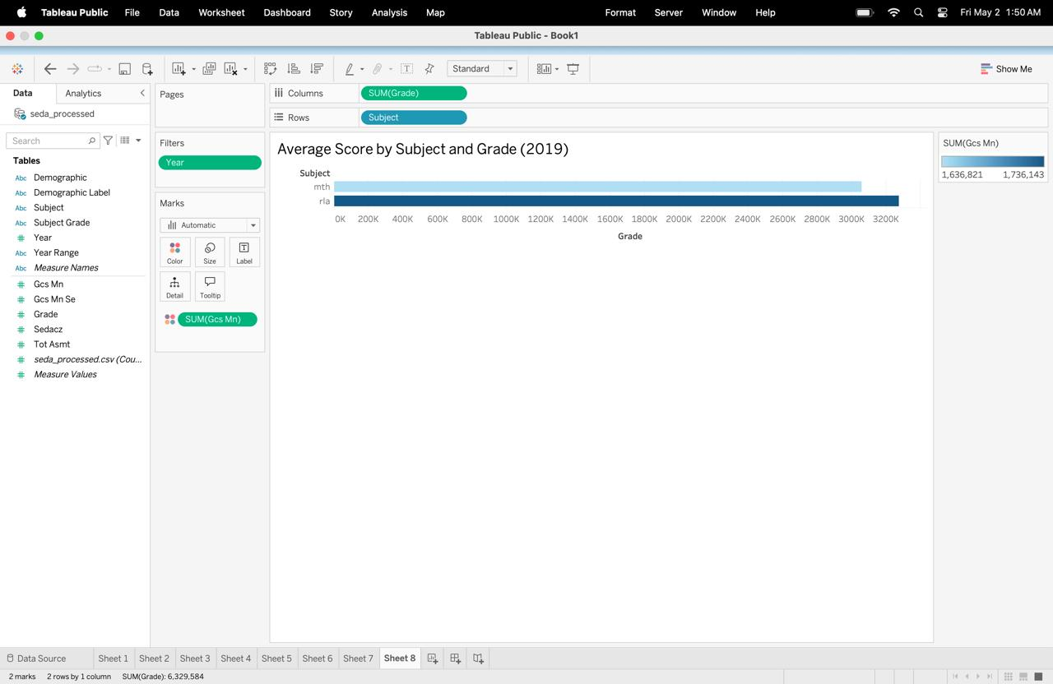

**Plot 9: Math Performance Trends by Demographic (2009–2019)**

This line chart captures the journey of Math performance for various demographic groups over a decade, spanning from 2009 to 2019. Each line represents a specific demographic group, allowing users to follow how their average scores have shifted year by year.

By observing the direction and slope of each line, users can easily spot which groups have shown steady improvement, which have remained stagnant, and which may have experienced declines. This long-term perspective is especially valuable for uncovering persistent achievement gaps or positive growth patterns among different populations. Overall, the chart serves as an essential tool for educators, analysts, and policymakers seeking to evaluate progress, understand disparities, and promote equitable outcomes in Math education across all student groups.

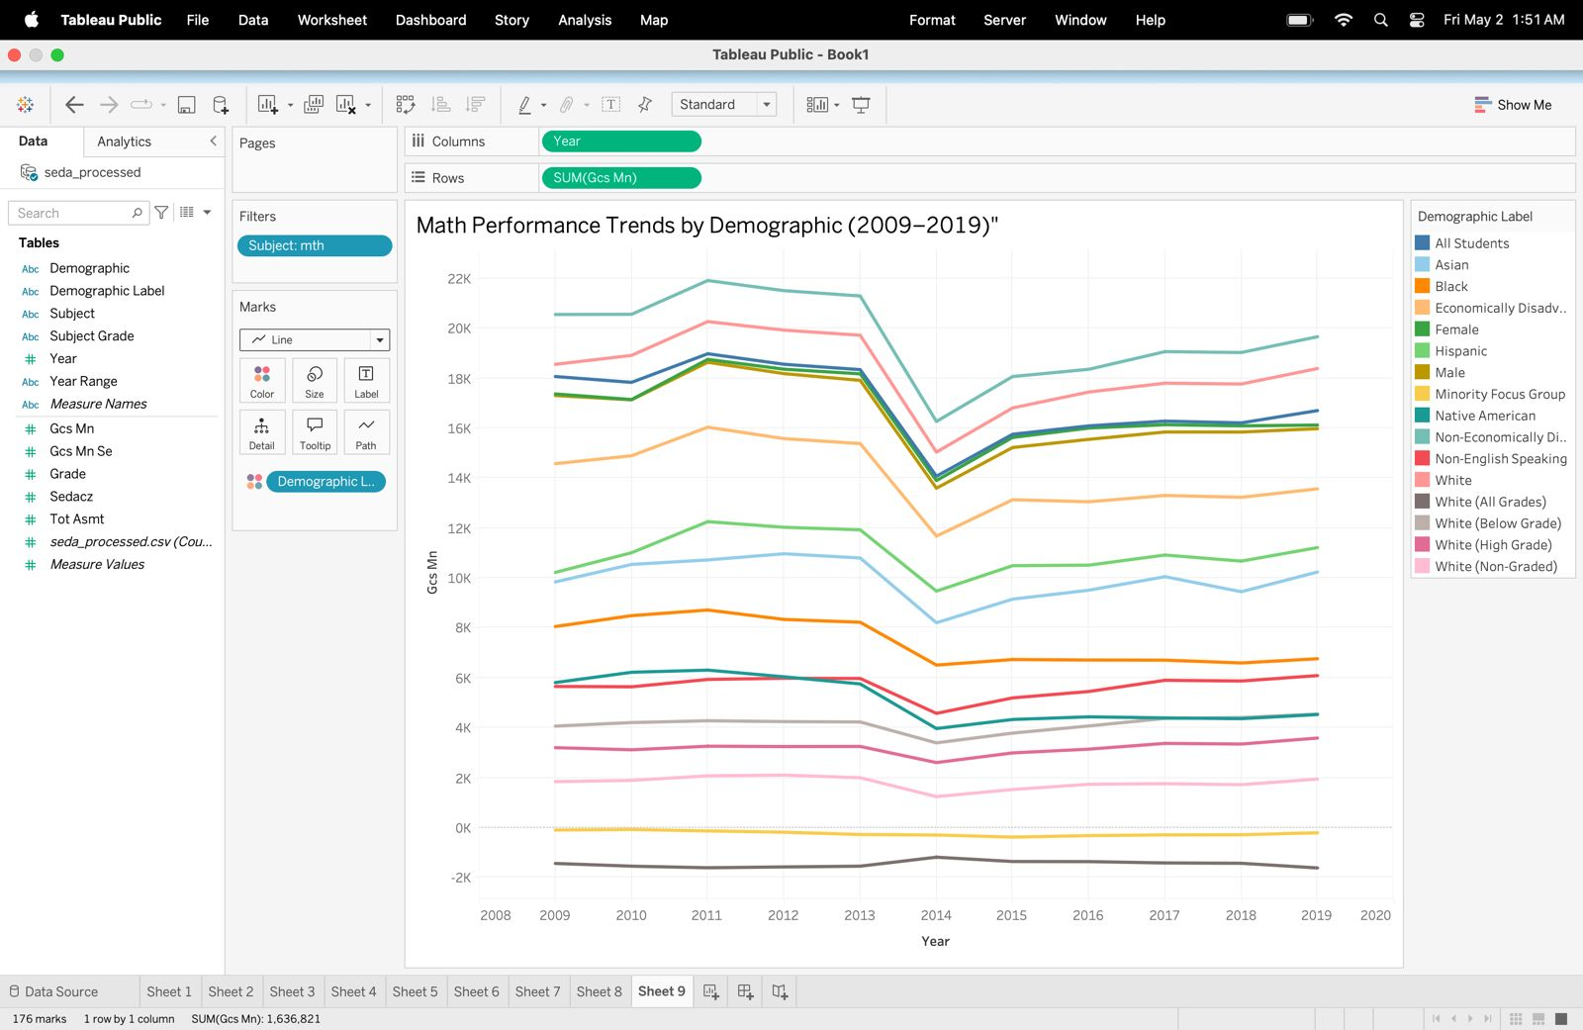

**Plot 10: Subject-Wise Score Comparison by Demographic (2019)**

This side-by-side bar chart compares the average Math and Reading scores of different demographic groups for the year 2019. For each group, two bars are displayed — one representing Math performance and the other showing Reading results. This arrangement makes it simple to observe subject-specific differences within each demographic.

The chart allows users to easily spot where certain groups excelled in one subject over the other or where gaps exist. By comparing the heights of the bars side by side, educators and policymakers can quickly identify which demographics may require focused academic support in Math, Reading, or both. This visualization serves as a valuable decision-making tool, helping stakeholders prioritize interventions and work towards closing subject-related achievement gaps to ensure all student groups are equally supported.

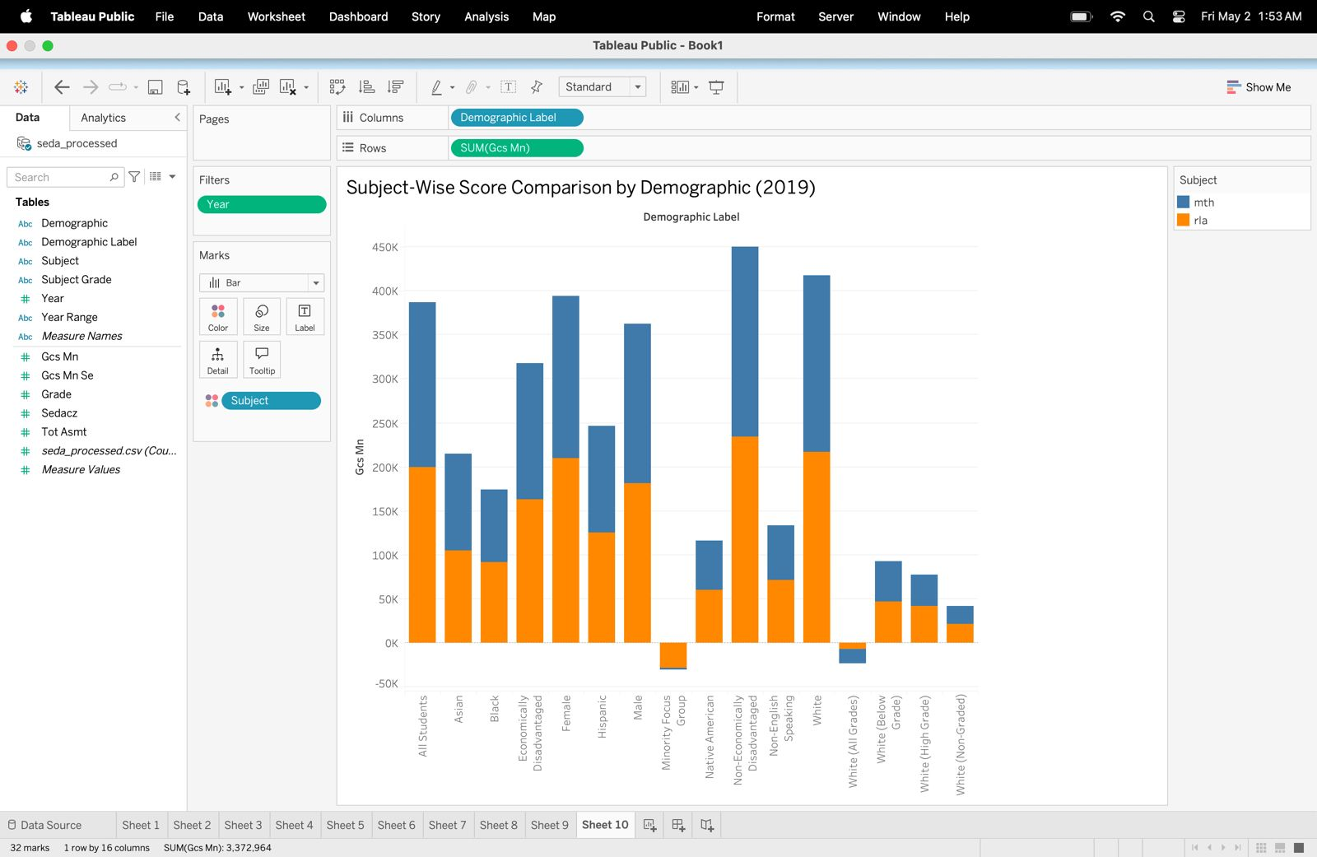

**Section 6: Interactivity**

The dashboard developed for this project integrates various interactive controls, designed to provide users with a flexible and dynamic way to explore the data. These features enable deeper analysis and allow users to customize their views based on specific criteria such as year, subject, demographic group, and grade level. By offering these options, the dashboard transforms into an intuitive and powerful analytical tool for stakeholders.

Below is a detailed overview of how interactivity is integrated into each visualization:

**Plot 1: Trends in Math and Reading Scores Over Time (Line Chart)**

Users can utilize the **Subject Filter** to seamlessly toggle between Math and Reading, enabling them to focus on subject-specific performance trends across the decade. The selected subject dynamically updates the chart, supporting easy comparisons.

**Plot 2: Average Scores by Demographic Group (2018) (Bar Chart)**

This chart offers filters for **Year (fixed to 2018)** and **Subject**, allowing users to analyze average scores across various demographic groups within the selected subject. These controls help reveal differences and potential performance gaps.

**Plot 3: Score Trends Over Time by Grade (Line Chart)**

The **Subject** and **Grade Filters** allow users to narrow down their view by subject and grade level, providing a focused analysis of how performance has changed over time for specific grade groups.

**Plot 4: Top-Performing Demographic Groups in Reading (2019) (Horizontal Bar Chart)**

Users can interact with the **Year (2019)** and **Subject Filters** to display and analyze the top-performing demographic groups in Reading. The sorted view makes it easy to compare and identify the highest-achieving groups.

**Plot 5: Assessment Count vs Average Score by Demographic (Scatter Plot)**

Filters for **Year**, **Subject**, and **Demographic Group** provide users with the ability to focus on specific populations and timeframes. This helps analyze the relationship between assessment frequency and academic performance.

**Plot 6: Average Scores by Year Range and Subject (Grouped Bar Chart)**

With **Subject** and **Demographic Group Filters**, users can compare performance across subject areas and demographic categories over defined year ranges, offering insights into overall trends and group-specific outcomes.

**Plot 7: Score Distribution Across Demographics (2019) (Box Plot)**

Filters for **Year (2019)**, **Subject**, and **Demographic Group** help users observe the variation in score distributions across different populations, identifying both consistency and potential outliers.

**Plot 8: Average Score by Subject and Grade (2019) (Heatmap)**

Users can refine the analysis using **Year (2019)**, **Subject**, **Demographic Group**, and **Grade Filters**, which enable an in-depth exploration of how scores vary by subject across grade levels.

**Plot 9: Math Performance Trends by Demographic (2009–2019) (Line Chart)**

With the **Subject Filter** locked to Math and the **Demographic Group Filter** available, this chart allows users to explore long-term trends across demographic groups and observe changes in Math performance over time.

**Plot 10: Subject-Wise Score Comparison by Demographic (2019) (Side-by-Side Bar Chart)**

Filters for **Year (2019)**, **Subject**, and **Demographic Group** allow users to compare Math and Reading scores side by side for each demographic group, making subject-specific disparities easy to identify.

**Overall Filter Placement and User Experience**

All interactive filters are strategically placed at the top of the dashboard to serve as global controls, affecting multiple visualizations simultaneously. In cases where filters are plot-specific, they are positioned beside the corresponding charts to allow localized adjustments. This thoughtful design ensures smooth navigation and enhances usability, allowing users to explore the data effortlessly and derive meaningful insights without leaving the dashboard environment.

**Conclusion**

This project delivered a thorough and insightful analysis of academic performance trends across U.S. public school districts, leveraging data from the Stanford Education Data Archive (SEDA) covering the years 2009 to 2019. The process began with an essential data preparation phase, where Python was used in place of Tableau Prep Builder to clean, reshape, and prepare the dataset for visualization. This step ensured the data was well-organized and ready for effective analysis.

The centerpiece of the project is the interactive dashboard developed in Tableau, featuring ten carefully designed visualizations. These charts and graphs provide a multidimensional view of key academic trends, highlighting shifts in Math and Reading scores across different grade levels, demographic groups, and over time. The visualizations help surface important patterns, such as areas of growth, persistent disparities, and subject-specific performance dynamics.

More importantly, the dashboard empowers users—including educators, policymakers, and other stakeholders—to make informed, data-driven decisions. Equipped with intuitive filters and interactive controls, users can easily explore the data from multiple perspectives. Whether analyzing performance by year, subject, student group, or grade, the dashboard offers valuable insights to help identify achievement gaps, track progress, and support strategic initiatives aimed at improving educational outcomes.

In conclusion, this project successfully combines robust data preprocessing with engaging, interactive visual storytelling. The result is a powerful analytical tool that not only reveals important trends but also supports efforts to foster equity and excellence in education.

**References**

Dashboard Link: <https://public.tableau.com/views/final_project_17461798560290/SEDAPerformanceDashboard?:language=en-US&publish=yes&:sid=&:redirect=auth&:display_count=n&:origin=viz_share_link>

Team’s Mural Link:

<https://app.mural.co/t/datavisualizationprojectgrou5824/m/datavisualizationprojectgrou5824/1744848337457/14741f42d7e009f6991ffa2eaa2c646ae738c982?sender=ue2b96469b44460ccc72c3659>